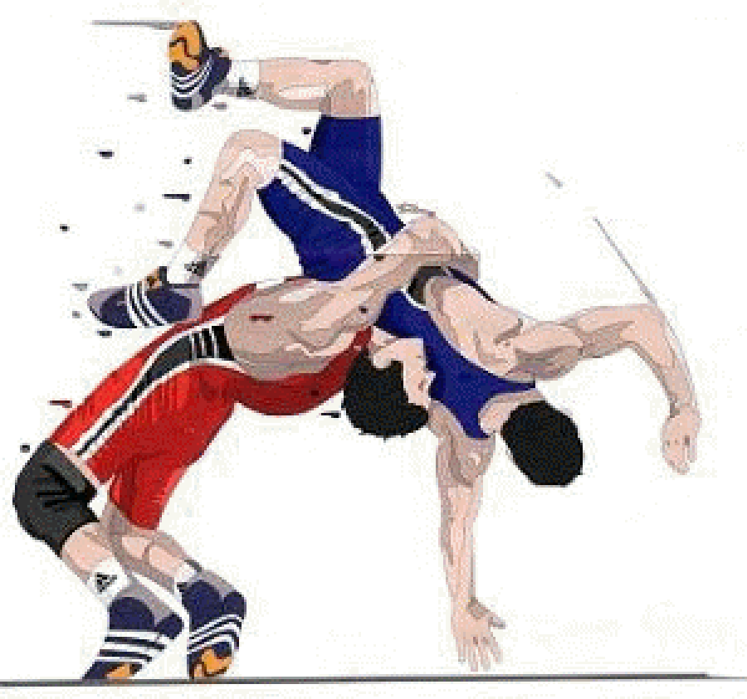 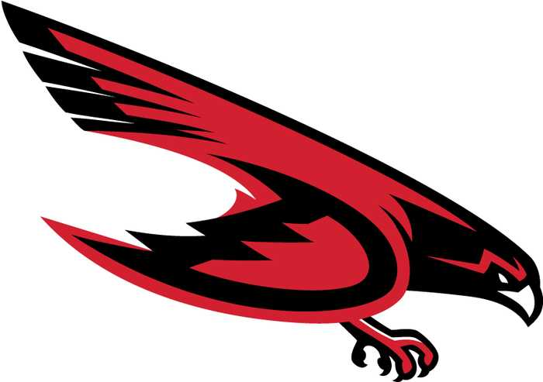

**2024 DUNEDIN FALCONS**

**JV Wrestling Schedule**

**HEAD COACH: KYLE GOODNOW**

|  |  |  |  |
| --- | --- | --- | --- |
| **Date** | **Home/Away** | **Opponent** | **Event Location** |
| 12/4/2024 | AWAY | P. PARK, LARGO, COUNTRYSIDE | COUNTRYSIDE |
| 12/6/2024 | AWAY | WEEKI WACHEE IBT | WEEKI WACHEE |
| 12/11/2024 | AWAY | BOCA CIEGA, OSCEOLA | OSCEOLA |
| 1/09/2025 | AWAY | BOCA CIEGA, LARGO, TARPON SPRINGS | TARPON SPRINGS |
| 1/15/2025 | AWAY | JV PCAC | BOCA CIEGA |
| 1/23/2025 | AWAY | ST. PETE, LARGO | ST. PETE |
| **1/29/2025** | **HOME** | **PHU, EAST LAKE, TARPON SPRINGS** | **DUNEDIN** |
| 2/4/2025 | AWAY | BOCA CIEGA, OSCEOLA, HOLLINS | HOLLINS |